**INTERNSHIP REPORT**

**ON**

**CREATION OF A**

**FLIGHT ASSISTANT CHATBOT**

**IN FULFILLMENT OF THE REQUIREMENTS**

**FOR**

**THE COMPLETION OF**

**SUMMER INTERNSHIP 2017**

**BY**

|  |  |
| --- | --- |
|  | **PRIYANSH DAS** |

**TABLE OF CONTENT**

**INTRODUCTION…………………………………………………………………. 3**

**WHERE I WORKED………………………………………………………....… 3**

**DUTIES PERFORMED……………………………………………………….… 4**

**CHATBOT……………………………………………………………………………. 4**

**FLOW DIAGRAMS…………………………….…………………………………. 6**

**SCREENSHOTS…………………………………………………….……………… 7**

**INTRODUCTION**

This report describes the activities carried out during an 8 week, final, fulltime internship program at Genpact - Digital. The document contains information about the organization and the responsibilities performed throughout the period between May and July 2017.

More than a plain account of tasks, the objective of this text is to reflect upon the experiences collected during the internship from the perspective of a B.Tech student. The first part of the report offers an overview of the organization, followed by an outline of all the duties carried out during this time. Following, it proceeds to describe in some detail of the project carried out and its respective analysis. Finally, the report wraps up with a few closing remarks and conclusions from the experience.

**WHERE I WORKED: GENPACT DIGITAL**

Global Leader in IT Services, Consulting, Technology and Digital Solutions with a Large Network of Innovation & Delivery Centers.

For Fortune 1000 enterprises looking to drive digital transformation within their businesses, Genpact AI solutions deliver a distinct competitive advantage. Genpact AI solutions integrate deep domain knowledge with leading AI technology and services to enable significant business value creation and accelerate the success of clients' digital transformations.

**DUTIES PRFORMED WHILE ON THE PROGRAM**

I was given the task of making a chatbot, which would interact with the user and give responses based on the intents of the user

**CHATBOT**

**FLIGHT ASSISTANT CHATBOT**

A chatterbot or chatbot aims to make a conversation between both human and machine. The machine has been embedded knowledge to identify the sentences and making a decision itself as response to answer a question. The response principle is matching the input sentence from user.

The chatbot I made asked the user interacting with the machine about the destination and the origin for which he/she is interested in getting the information of.

The chatbot then asked the date of departure as well as the preferred time and the number of passengers.

The chatbot is trained to accept the values like destination, origin, time, date and passengers. These values can be provided by the user all-at-once or one-by-one.

Once the values are accepted by the chatbot then it searches the internet and gives the cheapest flight available.

**Back End:**

IBM WATSON

Watson is a question answering computer system capable of answering questions posed in natural language.

A set of questions were user to train Watson. Using the conversation API, the chatbot was able to interact with the user.

Dialogs were nested in such a way that the user can provide the information all-at-once or one-by-one.

**ENTITIES**

Named-entity recognition (NER) (also known as entity identification, entity chunking and entity extraction) is a subtask of information extraction that seeks to locate and classify named entities in text into pre-defined categories such as the names of persons, organizations, locations, expressions of times, quantities, monetary values, percentages, etc.

**INTENTS**

Intents are the intentions of the end-user, these intentions or intents are conveyed by the user to your bot.

Example:

I WANT TO [BOOK A FLIGHT]**INTENT**  [FROM INDIA]**ORIGIN** [TO AUTRALIA]**DESTINATION** [TOMORROW]**DATE** [MORNING]**TIME** FOR [2 PASSENGERS]**PASSENGERS**



All the context variables are then sent to the QPX Express API using POST method.

It is used to search the flights all over the web. Then the cheapest of them all is selected and result is displayed to the end user. AJAX is used to dynamically update the webpage without even reloading the webpage.

**FRONT END:**

**JAVASCRIPT:**

**jQuery** is a cross-platform JavaScript library designed to simplify the client-side scripting of HTML. It is free, open-source software using the permissive MIT license.Web analysis indicates that it is the most widely deployed JavaScript library by a large margin.

An environment local server was able to connect with the IBM Watson.

JSON:

In computing, **JavaScript Object Notation**  is an open-standard file format that uses human-readable text to transmit data objects consisting of attribute–value pairs and array data types (or any other serializable value). It is a very common data format used for asynchronous browser/server communication.

All the context variables are retrieved from the conversation payload and then sent to QPX. Unless and until all the variables are not present, there wont be any service hit.

$.ajax({

type: "POST",

url: "https://www.googleapis.com/qpxExpress/v1/trips/search?key={APP KEY} ",

contentType: 'application/json',

dataType: 'json',

**SERVER:**

A local server was set up which can be accessed through the web browser at localhost:3000

var server = require('./app');

var port = process.env.PORT || process.env.VCAP_APP_PORT || 3000;

server.listen(port, function() {

// eslint-disable-next-line

console.log('Server running on port: %d', port);

});

Dotenv:

Dotenv is a zero-dependency module that loads environment variables from a .env file into process.env. Storing configuration in the environment separate from code is based on The Twelve-Factor App methodology.

require('dotenv').config({silent: true});

**FLOW DIAGRAMS**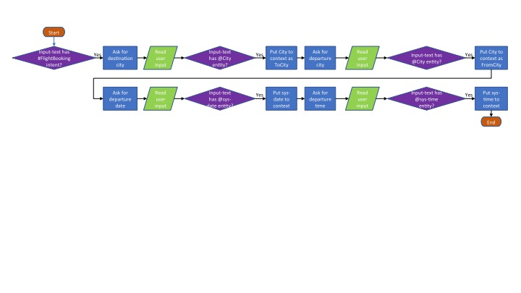

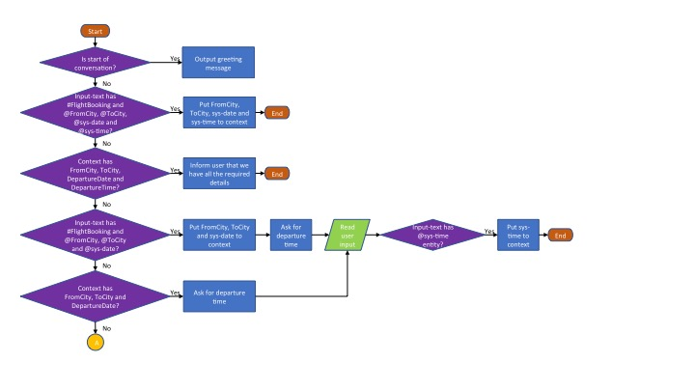

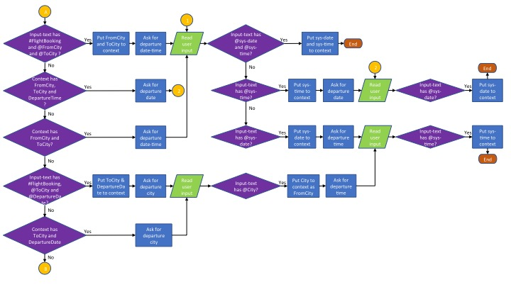

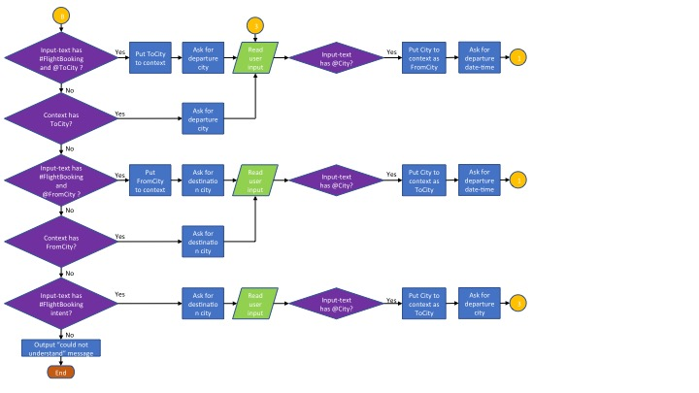

**SCREENSHOTS:**

To start the server:-

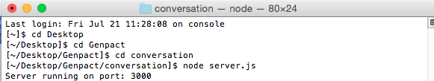

Talk to the chatbot

